Project A, Part 2: Character Prototype
Group 4

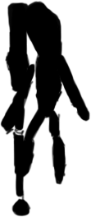
As you enter the game, you take on the persona of an intellect guy, called Astral, who uses his intellect and prism to bend light to his will. Once you get accustomed to your prism, you’ll find that some colors will have different effects with the use of sunlight. Switching to attack mode reinforces the light-source to a whole new level; capable of fending of enemies & danger.
Within the game are varying types of enemies which are each affected by various colors of light. You will quickly figure out which light colors work best for each situation as you advance through the levels.

Move at your own pace sort of puzzle game, using a prism and varying lights to solve puzzles while making it through varying difficulty level obstacle courses
Core mechanics: The prism itself, obstacle courses, any object that’s going to be moved via use of the prism. As well as any sort of creatures that will be attacking
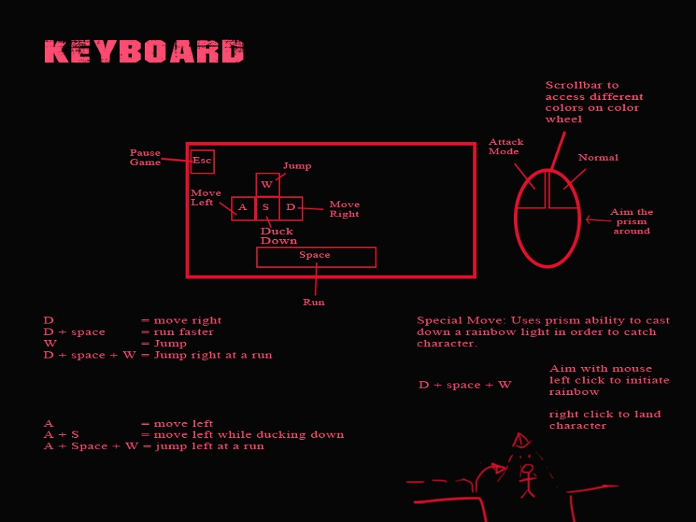
Control Map:

Astral:
W, A, D - (walk, run, jump)
Spacebar – Runs faster
Prism: Used via mouse movements to attack in normal mode and a slightly more aggressive mode

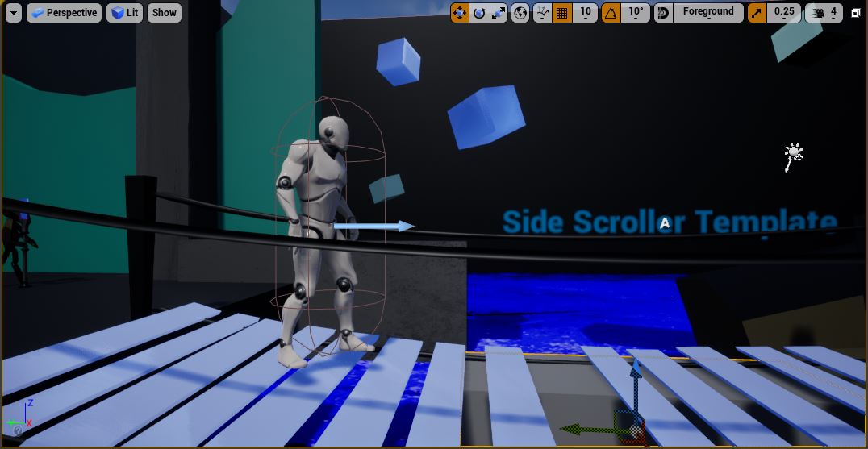
Camera Parameters – 2D Sidescroller Game

Characters – Astral & Prism
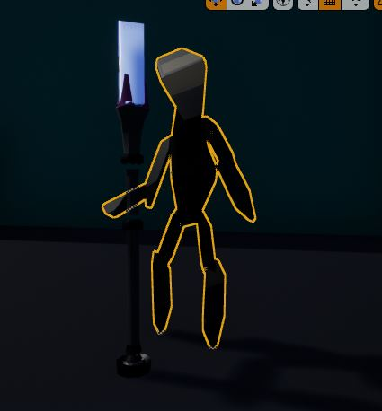
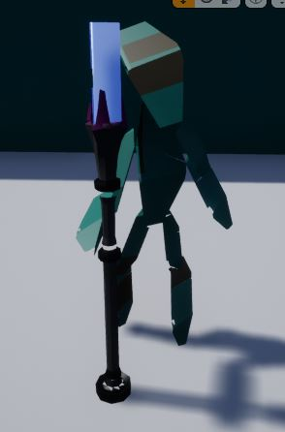

Game Training Stage
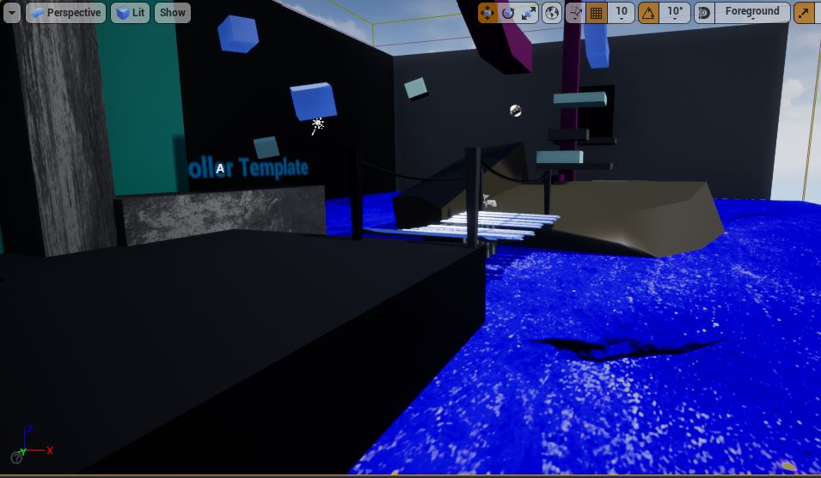

The training stage is to be used before the start of the game to train players how to use the controls in a setting where there isn’t any pressure.
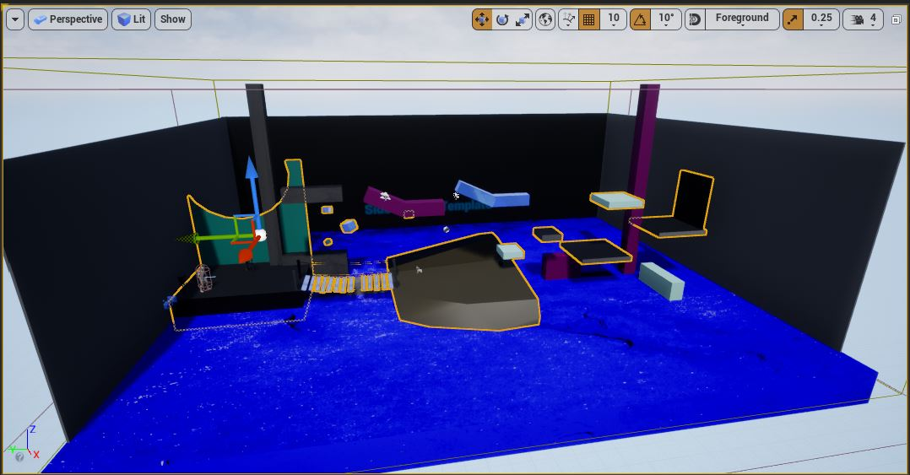
It’s meant to help demonstrate what both characters are capable of doing, as well as giving players a chance to get used to the keyboard/mouse control combination.

